This is a Sample Title for an extended abstract submitted to
6th IWA-YWP MEXICO Conference 2022

First page (Authors information and abstract)

Author Name¹, Author Name², initials then surnames, separated by commas, appear here
¹This is the first author’s affiliation (e-mail: water@ imaginaryaddresss.com)
²This is the second author’s affiliation (e-mail: water2@ imaginaryaddresss.com.mx)

Keywords: Three to five keywords separated by; semi-colons

ABSTRACT

Explain the topic justifying your project, methodology, results and conclusions, in 250 words.

Second and third page (Extended abstract)

INTRODUCTION
Write the background that justifies the topic of your project and write the research objective.

METODOLOGY
Briefly explain the techniques used for your research, complementing it with the regulations established for it.

DISCUSSION AND RESULTS
Explain the results that you include in your graphs and / or tables, compare them with what has already been reported.

Table 1. This is an example of table layout. It shows the dimensions of the text area to be used for Water Science and Technology articles and of international and US paper sizes (and the consequent recommended margin settings). Note that a minimum number of horizontal rules and (usually) no vertical rules are used.
 | Text area | A4 paper |  |  | US (Imperial) paper
 | (mm) | (mm) | (in) |  | (mm) | (in)
Depth | 250 | 297 | 11.69 |  | 279.32 | 11.0
Top/bottom margin | - | 25 | 1.0 |  | 15 | 0.6
Width | 170 | 210 | 8.27 |  | 215.84 | 8.5
Left/right margin | - | 30 | 0.8 |  | 23 | 0.9

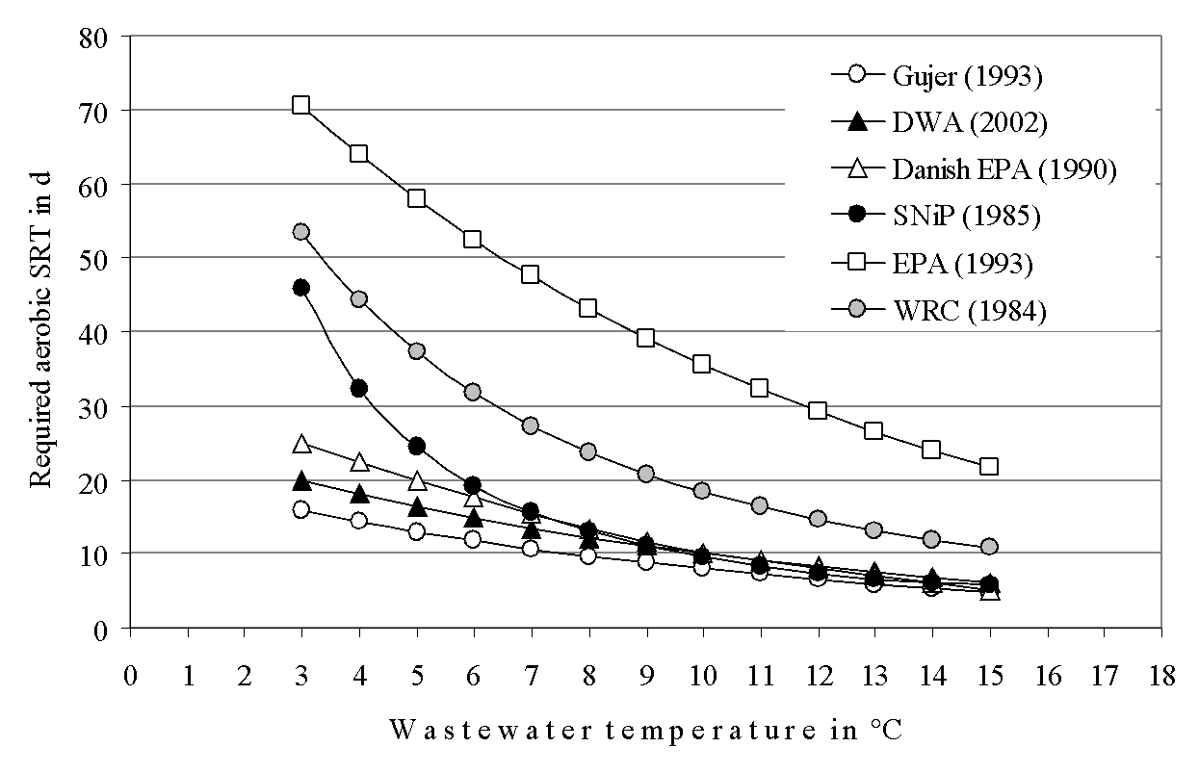

(ºC)
( d )
Figure 1. This is a style for Figure legends used for IWA. “Figure 1” should be in bold. Figure legends should appear below figures.
CONCLUSIONS
Based on the results obtained, your research objectives and your hypothesis, what can you say? was the hypothesis met?, was the objective achieved?, is there more to be done on the topic?

ACKNOWLEDGMENT
Thank the institutions that financed the project.

REFERENCES

This is a style for references (9pt Times New Roman).
Andrews, J.F. (1993) Modeling and simulation of wastewater treatment processes. Wat. Sci. Tech. 28(11/12), 141–150.
Billing, A.E. (1987) Modelling techniques for biological systems. M.Sc. thesis, Dept Chem. Eng., Univ. of Cape Town, Rondebosch 7700, South Africa.
Billing, A.E. and Dold, P.L. (1988a) Modelling techniques for biological reaction systems. 1. Mathematic description and model representation. Wat. SA 14(4), 185–192.
Billing, A.E. and Dold, P.L. (1988b) Modelling techniques for biological reaction systems. 2. Modelling of the steady state case. Wat. SA 14(4), 193–206.
Billing, A.E. and Dold, P.L. (1988c) Modelling techniques for biological reaction systems. 3. Modelling of the dynamic case. Wat. SA 14(4), 207–218.
Casey, T.G., Ekama, G.A., Wentzel, M.C. and Marais, G.v.R. (1993) An hypothesis for the causes and control of low F/M filamentous organism bulking in nitrogen (N) and nutrient (N & P) removal activated sludge systems. In Proc. of the IAWQ First Int. Conf. on Microorganisms in Activated Sludge and Biofilm Processes, Paris, 27–28 September.

MAJOR HEADINGS
There are three levels of headings. Please do not number them. Major headings are typed bold in 12pt upper case (capital letters), with two lines space above and none below. The first paragraph – text set with no indent but justified. This is our preferred style for all first paragraphs after headings. [12pt Times typeface]. The maximal length of your extended abstract is to be two A4 pages of text including figures, tables. Abstracts should be provided in electronic form. Your extended abstract should be submitted as a Microsoft Word document. Please do not supply your typescript as a PDF.

Minor headings
Minor headings are in 12pt bold type, not indented, with one line of space above and none below. Do not number headings.

Sub-headings. Sub-headings are typed in 12pt italic, not indented, with the paragraph running on after a full stop; there is one line of space above.

All subsequent paragraphs are indented and justified and be typed to fill the full depth of the text area. Authors should not add their own macros. Please supply only the final version of your file (with no hidden text) so as to avoid any risk of old versions of the text being used in error. Your submission should include the background and nature of issue or problem, your findings and results, and the significance and impact of your presentation on the topic of the conference. The references should be indicated this way (Daims, 2001). Do not link numbers of pictures/tables with numbers in the text. Do not number pages.

